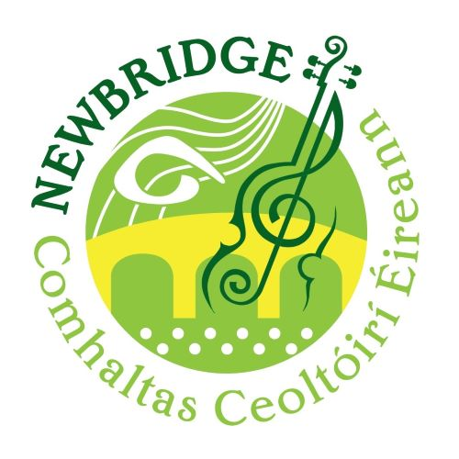
Newbridge CCE Slow Session Tunes

Britches Full of Stitches
The Kerry Polka

The Humours of Glendart
Saddle The Pony
Tobin’s Favourite

Roddy Mc Corley
The Dawning Of The Day

The Road to Lisdoonvarna
The Brosna Slide

The Lisnagun Jig
The Boys of the Town

Oro Se Do Bheatha Bhaile
Finnegan’s Wake
The Boys of Bluehill
Off to California

The Boyne Hunt
Shannon Breeze
Red Haired Lass

The Mountains of Pomeroy
The Foggy Dew

The Haunted House
My Darling Asleep
Club Ceili

The Newmarket Polka
Ballydesmond Polka No. 3

Sonnys Mazurka
Shoe the Donkey

The Geese in the Bog
The Connaughtmans Rambles
Out on the Ocean

John Walsh’s Polka
Paddys Polka No.2

Deirdre’s Fancy
The Dusty Miller

O’Keefe’s Slide
Denis Murphy’s Slide

Ballydesmond Polka No.2
Ballydesmond Polka No. 1

The Harvest Home
Cronin’s Hornpipe

Going to the Well for Water
Dingle Regatta

The South Wind
Paddy’s Green Shamrock Shore

Shane O’Neill’s March
The Centenary March

