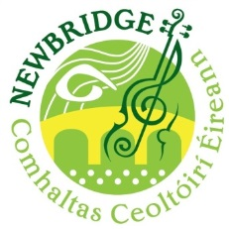
Co. Derry Fleadh Cheoil – Derry City
25th May 2019

Newbridge CCE Entry Form

This year’s Derry Fleadh will take place in Derry City from 23th-27th May, with solo/duet/trio competitions being held in St. Brigid’s College, Glengalliagh Road, Derry on Saturday, 25th May.

In addition to group and solo instrumental and singing competitions at U-12, 12-15, 15-18 and O-18 age groups, there’s an U-9 tin whistle competition for younger players. A full list of competitions and rules can be found here - https://comhaltas.ie/images/press_room/rialacha_fleadhanna_ceoil_2017_english.pdf

To take part, fill out the form below and return by Friday, 12th April – there are no entry fees for Comhaltas members.

--------------------------------------------------------------------------------------

Name _____________________________________________ DOB (if U-18) ______________

Age Group (determined by age on 1st January 2019) __________

Competition 1 __________________________________________________________________

Competition 2 _________________________________________________________________

Competition 3 _________________________________________________________________

Competition 4 _________________________________________________________________

Competition 5 _________________________________________________________________

* Miscellaneous competition - please name your instrument ______________________

* Accompaniment competition - please name your instrument ___________________

* Duet competition, please name both competitors, their DOB and instrument

_______________________________________________________________________________

_______________________________________________________________________________

* Trio competition, please name all competitors, their DOB and instrument

_______________________________________________________________________________

_______________________________________________________________________________

_______________________________________________________________________________

